MENEDŻERSKA AKADEMIA NAUK STOSOWANYCH W WARSZAWIE  
  
53 DPH COMPUTER ENGINEERING

  
  
  
Prepared by   
Tonderai Mapwashike 76776  
  
Advanced Software development Techniques   
  
SUPERVISOR  
  
Jakub Slowik  
  
  
2023POLAND, EU

New remote repository  
  
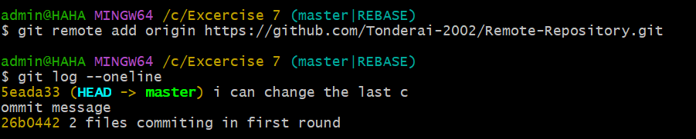  
  
Git Remote, Git Fetch, Git Push, Git Pull, Git Branch  
  
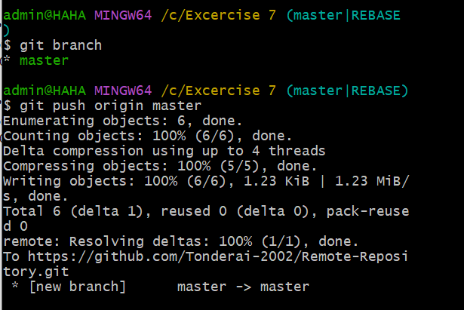

Execute fast-forward merge.

